VLSI (VERY LARGE SCALE INTEGRATION) INTERNSHIP TASK – 1

What is VLSI?
VLSI (Very Large Scale Integration) is the process of designing integrated circuits by combining millions/billions of transistors onto a single chip. The design flow is the structured sequence of steps engineers follow to go from an idea to a working, manufacturable chip.
Stages of the VLSI Design Flow
1. Specification - Define what the chip needs to do functionality, performance, power, area, and cost targets. This is the requirements document everything else is built against.
2. Architectural Design - Decide the high-level structure: number of blocks/modules, data paths, memory, interfaces, and how they interact. This is the system-level blueprint before any detailed coding.
3. RTL Design - Describe the actual digital logic using a Hardware Description Language (Verilog or VHDL) at the Register Transfer Level (RTL) i.e., describing how data moves between registers and what logic operates on it each clock cycle.
4. Functional Verification - Simulate the RTL code with testbenches to check that the logic behaves correctly for all expected inputs, before spending any effort on physical implementation. Bugs caught here are far cheaper to fix than bugs caught later.
5. Logic Synthesis - Convert the RTL code into a gate-level netlist — i.e., translate the HDL description into actual logic gates (AND, OR, NAND, flip-flops, etc.) from a standard cell library, optimized for timing, area, and power.
6. Floorplanning - Decide the physical layout: where major blocks, I/O pads, and power structures go on the chip die. This sets the foundation for placement and routing.
7. Placement - Place each individual standard cell (gate) from the netlist into specific physical locations within the floorplan, optimizing for wire length and timing.
8. Clock Tree Synthesis (CTS) - Build the clock distribution network so the clock signal reaches every sequential element (flip-flops) with minimal skew and delay.
9. Routing - Connect all the placed cells with actual metal wires according to the netlist connectivity, while obeying design rules (spacing, width, layers).
10. Physical Verification (DRC / LVS)
- DRC (Design Rule Check): Confirms the layout obeys the foundry's manufacturing rules.
- LVS (Layout vs. Schematic): Confirms the physical layout matches the original logical netlist.
11. Static Timing Analysis (STA) - Verify that all signal paths meet timing requirements (setup/hold) across the chip without needing to simulate every possible input — done by analyzing path delays directly.
12. Fabrication - The foundry manufactures the actual silicon wafer based on the GDSII file, using photolithography and many other semiconductor processes.
13. Packaging & Testing - The fabricated die is packaged (bonded into a chip package) and tested to ensure it meets functional and electrical specifications before shipping.

LOGIC GATES AND THEIR TRUTH TABLES

AND Gate
The AND gate is a basic gate that performs logical multiplication. It has two (or more) inputs and one output. The output goes HIGH (1) only when all inputs are HIGH. If even one input is LOW (0), the output stays LOW. Its symbol is a flat-backed shape with a rounded (D-shaped) front. It's used wherever an action should happen only if multiple conditions are simultaneously true — e.g., enabling a circuit only when both a "power" signal and an "enable" signal are active.

INPUT 1 | INPUT 2 | OUTPUT
0 | 0 | 0
0 | 1 | 0
1 | 0 | 0
1 | 1 | 1

OR Gate
The OR gate performs logical addition. The output is HIGH if at least one input is HIGH, and LOW only when all inputs are LOW. Its symbol has a curved back and a pointed front. OR gates are used when any one of several conditions should trigger an action — e.g., an alarm that should go off if either a door sensor or a window sensor is triggered.

INPUT 1 | INPUT 2 | OUTPUT
0 | 0 | 0
0 | 1 | 1
1 | 0 | 1
1 | 1 | 1

NOT Gate (Inverter)
The NOT gate is the simplest gate — it has only one input and one output, and it simply inverts the input: a 1 becomes 0, and a 0 becomes 1. Its symbol is a triangle with a small circle (bubble) at the output, where the bubble represents inversion/negation. It's used to generate the complement of a signal, which is essential in building other gates and in control logic.

INPUT | OUTPUT
0 | 1
1 | 0

NAND Gate
NAND = NOT + AND. It behaves exactly like an AND gate followed by an inverter — output is LOW only when all inputs are HIGH, and HIGH otherwise. Symbol-wise, it's an AND gate shape with a bubble at the output. NAND is significant because it's a universal gate — any other logic gate (AND, OR, NOT, etc.) can be built using only NAND gates, which makes it very popular in actual chip fabrication.
INPUT 1 | INPUT 2 | OUTPUT
0 | 0 | 1
0 | 1 | 1
1 | 0 | 1
1 | 1 | 0

NOR Gate
NOR = NOT + OR. It's an OR gate followed by an inverter — output is HIGH only when all inputs are LOW, and LOW otherwise. Symbol-wise, it's an OR gate shape with a bubble at the output. Like NAND, NOR is also a universal gate and can be used to construct any other basic gate.

INPUT 1 | INPUT 2 | OUTPUT
0 | 0 | 1
0 | 1 | 0
1 | 0 | 0
1 | 1 | 0

XOR Gate (Exclusive OR)
The XOR gate outputs HIGH only when the inputs are different from each other (one is 0 and the other is 1). If both inputs are the same (both 0 or both 1), the output is LOW. Its symbol looks like an OR gate but with an extra curved line at the input side. XOR is widely used in arithmetic circuits (like adders), parity checking, and comparators, since it essentially detects "difference" between two bits.

INPUT 1 | INPUT 2 | OUTPUT
0 | 0 | 0
0 | 1 | 1
1 | 0 | 1
1 | 1 | 0

BASIC LOGIC GATES SIMULATION

AND GATE
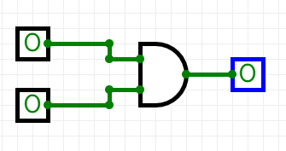
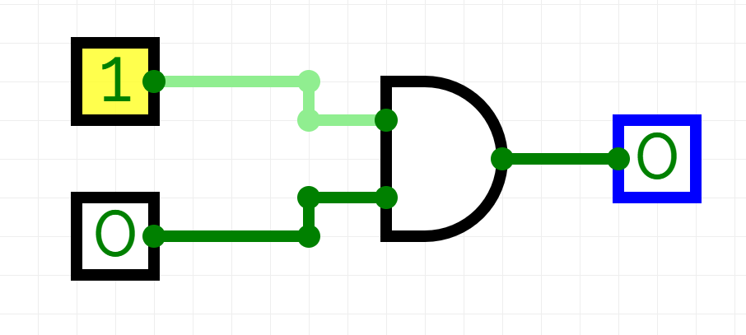

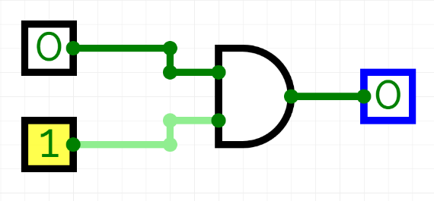
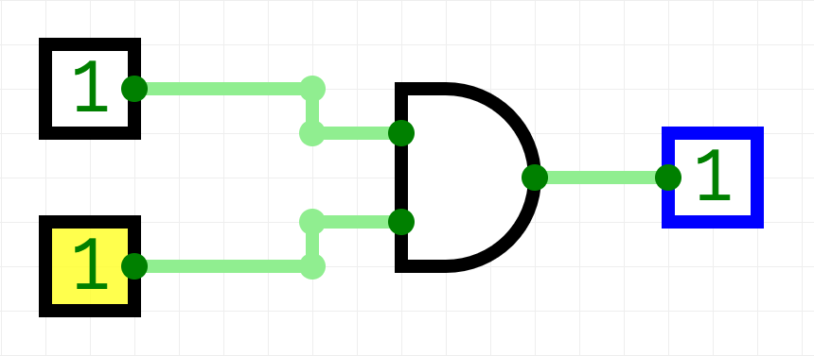

OR GATE

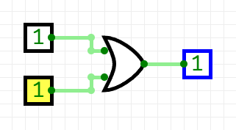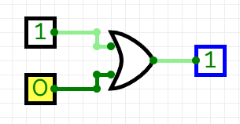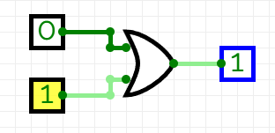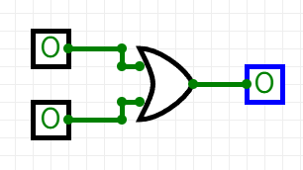

NOT GATE

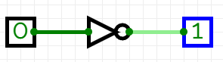

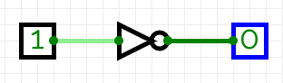

NAND GATE

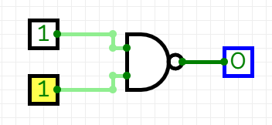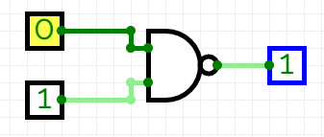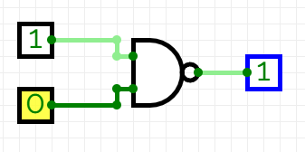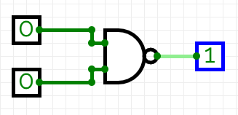

NOR GATE

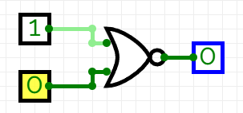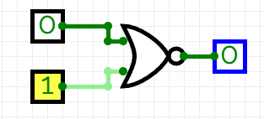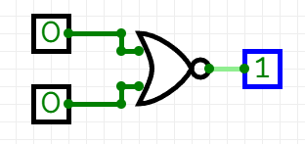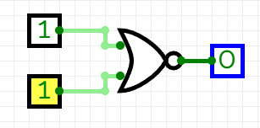

XOR GATE

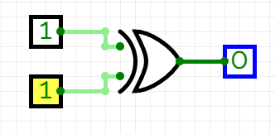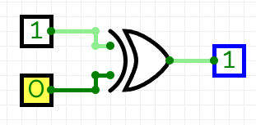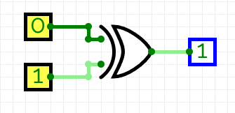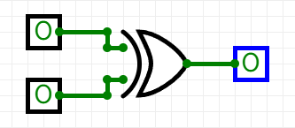

HALF ADDER

A Half Adder is a basic combinational circuit used in digital electronics to add two single binary digits (bits). It's one of the fundamental building blocks of arithmetic circuits inside a processor's ALU (Arithmetic Logic Unit).
What it does
It takes two 1-bit inputs, A and B, and produces two outputs:
- SUM — the result of adding A and B
- CARRY — the carry-out bit, generated when both inputs are 1 (since 1+1 = 10 in binary, which needs a carry)
A half adder is constructed using just two basic gates:
- An XOR gate to compute the SUM: SUM = A ⊕ B
- An AND gate to compute the CARRY: CARRY = A · B
Both gates share the same two inputs, A and B.

TRUTH TABLE

A | B | SUM | CARRY
0 | 0 | 0 | 0
0 | 1 | 1 | 0
1 | 0 | 1 | 0
1 | 1 | 0 | 1

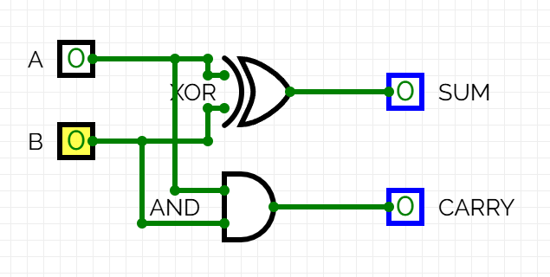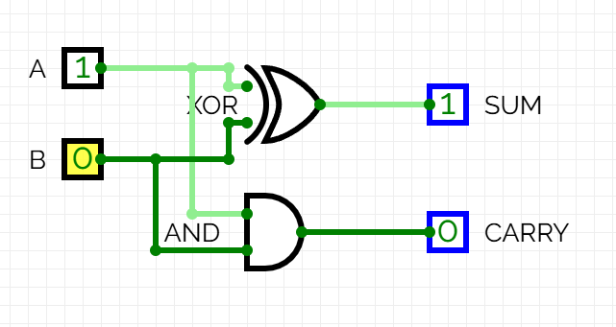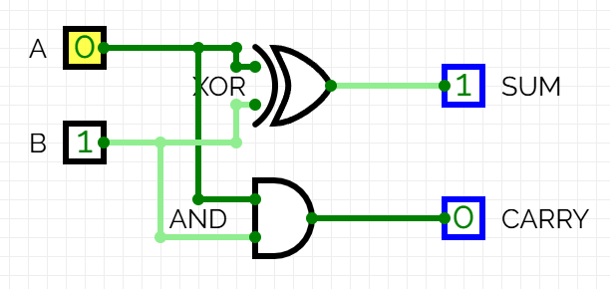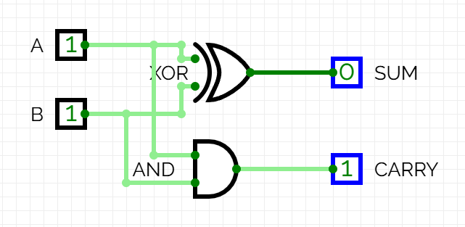

OBSERVATIONS FROM SIMULATIONS

AND Gate
When A and B were varied through all four combinations, the output Y remained LOW for three of the four cases and rose to HIGH only in the single case where both A and B were HIGH simultaneously. The transition of Y to HIGH occurred a short propagation delay after the later of the two input transitions, confirming that both inputs must be stable HIGH before the output responds. This exactly matched the AND truth table.
OR Gate
The output Y was observed to go HIGH as soon as either A or B (or both) transitioned HIGH, and it returned LOW only during the interval where both inputs were simultaneously LOW. Unlike the AND gate, Y responded to the first input that went HIGH, not the last — showing OR's "any true" behaviour clearly on the waveform.
NOT Gate
The output waveform was a clean inversion of the input: every rising edge on A produced a corresponding falling edge on Y after a small propagation delay, and every falling edge on A produced a rising edge on Y. The output never matched the input level at any point in the simulation, confirming correct inversion.
NAND Gate
The output Y stayed HIGH for all input combinations except A=1, B=1, where it dropped LOW. Comparing this waveform side-by-side with the AND gate's waveform showed they were exact inverses of each other at every time step, confirming NAND = NOT(AND).
NOR Gate
The output Y stayed LOW for all input combinations except A=0, B=0, where it rose HIGH. This waveform was the exact inverse of the OR gate's waveform at every time step, confirming NOR = NOT(OR).
XOR Gate
The output Y went HIGH only during the two intervals where A and B held different logic levels (A=0,B=1 and A=1,B=0), and dropped LOW whenever both inputs matched (00 or 11). This "difference-detecting" behaviour was clearly visible as Y toggling independently of whether the inputs were both rising or both falling — only their disagreement mattered.

HALF ADDER
SUM Output
The SUM waveform tracked the inputs exactly like an XOR operation: it rose HIGH whenever A and B held different logic levels (A=0,B=1 or A=1,B=0), and stayed LOW whenever both inputs matched (00 or 11). A small propagation delay was visible between the input transition and the SUM response — slightly larger than a single gate's delay, since SUM is generated by the XOR gate, which is itself often built internally from multiple gate stages.
CARRY Output
The CARRY waveform stayed LOW for every input combination except A=1, B=1, where it rose HIGH — exactly matching the behavior of a standalone AND gate. Its propagation delay was shorter than SUM's, since CARRY passes through only a single AND gate with no intermediate logic stages.
Combined Behavior
At A=1, B=1, both outputs were observed together: SUM dropped to 0 while CARRY rose to 1 — correctly representing the binary result "10" (decimal 2) for 1+1. At no point did SUM and CARRY both read HIGH simultaneously for the same stable input combination, which is expected, since no single 2-bit input combination produces a binary sum requiring both bits set.

